Lab 8
Exercise 1.
Write a program that creates and fills a two-dimensioned array of doubles called balances having two rows and five columns. Use the initialiser list provided below to populate the array.
Top of Form
Write a for loop to total the contents of the array balances.
Output the total.
Sample Output
Exercise 2
Read in the following rainfall data from the keyboard into a 2D array for 2 geographical regions covering 3 months, Jan-Mar.
3.2 | 3.4 | 3.1
4.7 | 6.0 | 4.3
Print out the values and the average rainfall formatted as shown below.
Sample Output
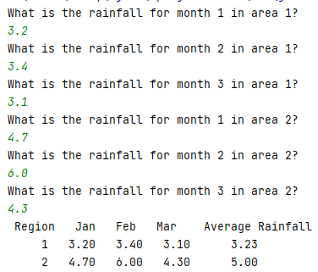
Exercise 3
Write a Java program which creates a 2D array with 20 rows and 20 columns.
Fill this array with all the numbers between 0 and 399, in steps of 1.
Print out the array
Sample Output
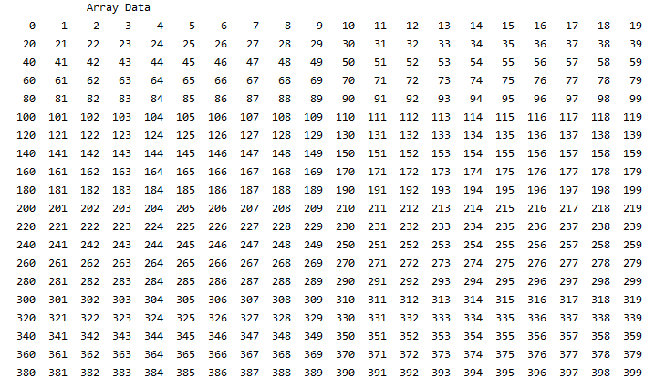

Exercise 4
Write a Java program which creates a 2D array with 20 rows and 2 columns. Fill the first column with all the numbers between 2 and 40, in steps of 2. In the second column place the value of the first col and the next row’s first col added together.
For the last row simply place the value of last row’s first column in to the second column.
Sample Output
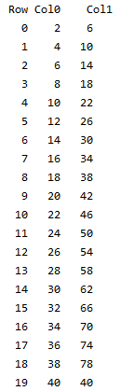
Exercise 5
What is the output of the following program?
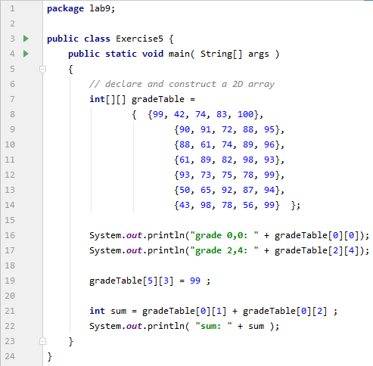
Exercise 6
Write a program which asks primary students to answer simple math problems such as
1 + 1 = ?
1 + 2 = ?
1 + 3 = ?
and so on. The two numbers must start at 1 and go to 12 (on both first and second number). Use two arrays that each contain values 1-12 but make sure to change the ordering of the values.
The program should keep asking questions till the user gets 3 wrong. It should then print out how many they got right. See sample output on the next page.
Sample Program
